Trends in Middle and High School Students' Tobacco Use: An Analysis of East Coast States from 2010 to 2017

Xinyi Luo, Huyen Nguyen, Maimouna Sanogo

1. Introduction and Hypothesis (10 points)

The use of tobacco among middle and high school youth has seen fluctuations over recent years. A study conducted in 2018 analyzed the trend and prevalence rates of tobacco use over the 2015-2017 period. The study revealed that while there was a noticeable decline in the use of traditional tobacco among students, the use of e-cigarettes substantially increased from 1.5% to 11.7%, emerging as the most commonly used tobacco product among both middle and high school students by 2017 (Anic et al., 2018). Moreover, approximately 11.7% of high school students and 5.6% of middle school students were current users of any tobacco products (Anic et al., 2018). This finding emphasizes the importance of targeted interventions to address the rising popularity of e-cigarettes among youth.

Demographics may play a role in the tobacco use of high school and middle students as well. A conducted study in 2019 analyzes the difference of tobacco use of students located in the urban and rural area. Through this research, the researchers found out that there is a higher chance of middle school and high school students living in rural areas to consume tobacco than students in urban areas. Compared with schools in the downtown, the rural area students consume 30 percent more in cigarettes and 160 percent more in smokeless tobacco. (Wiggins et al., 2019)

Access to tobacco advertisements can be another factor in the increasing use of tobacco by middle school and high school students from 2011 to 2017. It appears that stores, magazines, and the Internet are the mediums to which middle school and high school students may access pro-tobacco advertisements. Middle and high school students have little difference in exposure rate. There is a significant decrease in students’ exposure to magazines. However, there is a great increase in exposure to internet tobacco advertisements. In this way, it would be important to have a higher standard in selecting and exposing pro-tobacco in mediums. (Dube et al., 2013).

Adolescents are particularly vulnerable to the adverse effects of tobacco use. Studies have shown that daily cigarette smoking during adolescence is linked to an increased likelihood of anxiety, mood disorders, and disruptive behavior. Furthermore, smoking during adolescence increases the likelihood of future substance use disorders, including alcohol, marijuana, and multiple drug use. (National Center for Chronic Disease Prevention and Health Promotion (US) Office on Smoking and Health, 2012).

To control and reduce the youth population from taking tobacco, the American Academy of Pediatrics introduced tobacco screening tools and advice. In this study, the researchers are applying the National Youth Tobacco Survey (NYTS) which asks teenagers some questions about the ways and frequencies of using tobacco. Health providers would provide suggestions based on the survey results. According to this research, the rate of tobacco screening significantly increased, with the rate of being advised not to use tobacco decreased. (Boakye et al., 2023) Thus, there is a need to adjust Healthcare policies to motivate more smokers to reduce and quit smoking.

Support and monitoring from parents play a role in helping middle and high school students decrease tobacco use. In the article in 2021, apart from taking age groups into account, the researchers considered gender as well. From this research, both parental support and parental monitoring led to a decrease in lifetime cigarettes and current cigarettes. To be more specific, there is little difference in how parents support and monitor their children of different age groups. Nonetheless, girls have a higher chance of parental monitoring than boys. (Mills et al., 2023).

After reviewing these researches, we decided to look at how different states in the East Coast of the US, types of tobacco, and frequency of tobacco use affect middle school and high school students.

1. Research question:

Evaluating middle school and high school students tobacco use throughout the years 2010 to 2017 focusing on East Coast states.

1. Hypothesis: Provide your Null and Alternative Hypothesis for your Research Topic.

**Null hypothesis:**

There is no difference in the use of tobacco products between middle school and high school students on the East Coast states throughout the years 2010 to 2017.

**Alternative hypothesis:**

High school students have higher rates of tobacco use than middle school students on the East Coast states throughout the years 2010 to 2017.

1. Specific Aims (10 points)

a. Develop specific aims (goals or objectives) related to your hypothesis.

1. To determine the tobacco use rate of middle school students on the East Coast states throughout the years 2010 to 2017.
2. To determine the tobacco use rate of high school students on the East Coast states throughout the years 2010 to 2017.
3. To determine if the differences between the tobacco use of middle school and high school students are statistically significant.

III. Quality Control and Data Integrity of Database (10)

Please refer to Appendix for all figures mentioned.

1. Reformat and clean data from the original dataset and describe how you did this. Upload to SPSS to conduct statistical analysis.

We are using the columns of YEAR, LocationAbbr, LocationDesc, TopicDesc, MeasureDesc, and Response of the dataset of Youth Tobacco Survey (YTS) Data. After reviewing the dataset, we found that there are missing values in the Response column. Thus, we decided to delete the missing columns in Response. Since we are only considering the dataset from 2010-2017, we need to remove irrelevant data from the years before 2010 and after 2017. Since we are only interested in East Coast states, our cleaned-up data only includes 17 states: Connecticut, Delaware, Florida, Georgia, Maine, Maryland, Massachusetts, New Hampshire, New Jersey, New York, North Carolina, Pennsylvania, Rhode Island, South Carolina, Vermont, Virginia and West Virginia. Furthermore, since the original dataset had cigarette use and smokeless tobacco data values in the same column, we decided to split the dataset into cigarette use and smokeless tobacco use. The original dataset for the Youth Tobacco Survey for this research is presented in Figure 1.1.

**Cleaning the Missing Response Values**

*Step 1. Converting String and Missing Response Values into Numerical Values*

The Response column indicates the frequency of tobacco use, whether youths have used tobacco and the frequency contains numerous missing values. These values need to be deleted to avoid errors and biases when analyzing the data. To clean the missing data, we first need to transform the values into numbers ranging from 1 to 4.

Using the Transform function, select Recode into Different Variables. Select Response from the list. The selected value will appear in the “String Variable → Output Variable:” box. After that, enter the name for the Output Variable. Select Change. The value in the “String Variable → Output Variable:” box will appear as “Response → responsenew” (Figure 1.2).

To turn the string values into numerical values, click on Old and New Values. The window “Recode into Different Variables: Old and New Values” will pop up. For Old Value, select System- or user-missing. for New Value, enter 1, then select Add. This will turn the missing values in the dataset into numerical values. To turn the Response values: Frequent, Ever, and Current into numerical values, select Value, enter “Frequent”, go to New Value, enter 2. Repeat the same process for the values Ever and Current. The “Old → New” box will show the string values of the Response columns and the new corresponding numerical values (Figure 1.3). Next, Click “Continue”, then “OK”. The new created column “responsenew” shows the numerical values corresponding to the string values in the Response column (Figure 1.4).

*Step 2. Removing the Rows with Missing Values in Response Column*

After the converting process, the numerical values for missing values is 1. To remove the missing values, go to Data, then select Select Cases. When the window “Select Case: If” pops up, select “responsenew”, then select If condition is satisfied. Click on If, and chose “responsenew” from the list.. Type “responsenew = 2 | responsenew = 3 | responsenew = 4” in the text box (Figure 1.5) to select the rows that need to be analyzed later. Click “Continue”. For the Output, choose “Delete unselected cases”(Figure 1.6). Click “OK”. This step will unselect all the cases with missing values, which is responsenew = 1, and remove them from the table.

After removing the missing values, the responsenew column is no longer needed, which will be deleted to avoid unnecessary variables and reduce the complexity of the dataset (Figure 1.8).

**Filtering the Year Range**

The research focuses on the youth use of tobacco throughout the years 2010 to 2017. Given that our original dataset contains data from 2004 and beyond, we refined our analysis to concentrate on 2010 through 2017. We used a filtering process in SPSS to isolate the relevant data and exclude any information from the years before 2010 and after 2017. To narrow down the dataset, use the Data function, then select Select Cases. Within the "Select" section of the screen, choose “If condition is satisfied” and select If . Input the condition “YEAR > 2009” within the “Select Cases: If” window to filter out the years after 2009. Click “Continue”.Then, choose the “Delete unselected cases” option under Output (Figure 1.9). Click "Continue" and the dataset will be filtered accordingly.

**Removing Irrelevant States Using the LocationAbbr Values**

For this study, we are focusing on the states from the East Coast. We selected the 17 states that are classified as the East Coast states. These states include: Connecticut, Delaware, Florida, Georgia, Maine, Maryland, Massachusetts, New Hampshire, New Jersey, New York, North Carolina, Pennsylvania, Rhode Island, South Carolina, Vermont, Virginia and West Virginia.

Within the dataset, there is a column known as LocationAbbr that contains the abbreviations for each state name. We used these values to select the 17 East Coast states to make the process more simple. To achieve this, select Select Case, then choose “If condition is satisfied” within the Select section of the window. Select If, then a new window “Select Cases:If” will pop up. Enter as follows in the text box (Figure 1.11):

LocationAbbr = 'ME' | LocationAbbr = 'NH' | LocationAbbr = 'VT' | LocationAbbr = 'MA' | LocationAbbr = 'RI' | LocationAbbr = 'CT' | LocationAbbr = 'NY' | LocationAbbr = 'NJ' | LocationAbbr = 'PA' | LocationAbbr = 'DE' | LocationAbbr = 'MD' | LocationAbbr = 'VA' | LocationAbbr = 'NC' | LocationAbbr = 'SC' | LocationAbbr = 'GA' | LocationAbbr = 'FL' | LocationAbbr = ‘WV’

After that, click “Continue”. Within the Output section, choose “Delete unselected cases”(Figure 1.12). Then click “OK”.

Figure 1.13 shows the output for location selection after the steps above had been completed. Because of the year range we selected for this study, there would not be 16 states present in the dataset. After cleaning the data, there are only 9 states that contain tobacco use survey information. These states include Delaware, New Jersey, Pennsylvania, Connecticut, Georgia, New Hampshire, North Carolina, South Carolina, and West Virginia.

As a result of data cleaning, this research would focus on 9 states on the East Coast: Delaware, New Jersey, Pennsylvania, Connecticut, Georgia, New Hampshire, North Carolina, South Carolina, and West Virginia.

**Removing Data Containing Gender Male and Female**

In our research, we did not choose to analyze smoking rate based on gender. However, the dataset we are using contains data of male, female and the overall (male and female). Therefore, we decided to clean the data that contain male and female, and we only kept the overall data. To remove this data, we performed the same steps with the Select Case function. We selected “Gender” when the column pops up, then selected “If condition is satisfied” and enter in the text box “ Gender= ‘Male’| Gender= ‘Female’”. Then, perform the same steps as the previous procedure.

**Splitting the Dataset into Two Separate Datasets: Cigarette Use( Youth) and Smokeless Tobacco Use (Youth)**

In the Youth Tobacco Survey dataset, there are two types of tobacco that youths use: cigarette and smokeless tobacco. We decided to split the dataset into two separate files, one for the use of cigarettes and one for the use of smokeless tobacco. Splitting the data would allow us to distinct the pattern of tobacco use in our analysis. It would also ensure quality control and consistency of the data by measuring and analyzing the specific types of tobacco used by youth.

Step1. Creating Table Cigarette Use (Youth)

To extract the data to a new table file, go to Data, then choose Select Cases. Select “If condition is satisfied”. Click If. There will be a new window “Select Cases: If” popping up. Within the text box, enter “TopicDesc = ‘Cigarette Use (Youth)’” (Figure 1.14). In the Output section, select “Copy selected cases to a new dataset”, enter the new dataset name. We have the dataset name as Cigarette Use (Youth). Click “OK”. A new dataset will be created, as shown (Figure 1.15).

Step 2. Creating Table Smokeless Tobacco Use (Youth)

Repeat the same steps as above. However, when getting to the “Select Cases: If” window, enter “TopicDesc = ‘Smokeless Tobacco Use (Youth)’” (Figure 1.17). Name the dataset Smokeless Tobacco Use (Youth).

We split this because the original data contains cigarette use, smokeless tobacco use and smoking cessation. We do not want to include the smoking cessation data in our analysis. Therefore, we chose to create new files that each contain the data for cigarette use and smokeless tobacco use for future analysis.

IV. Statistical Analysis Part I: Descriptive Statistics to Analyze Data (20 points)

a. Descriptive Statistics

**Smokeless Tobacco Use**: Percentage of students who have reported using smokeless tobacco such as chewing and sniffing *Levi Garrett, Redman* and *Skoa*l products.

The descriptive statistics table of smokeless tobacco usage encompasses 177 observations, with a range of 25.8. The minimum observed usage rate was 0%, while the maximum was 25.8%. The data shows a mean prevalence rate of 6.181% and a standard deviation of 5.9565. The high standard deviation and the variance of 35.480 indicate considerable variability in the data. The skewness value of 1.327 suggests that the distribution of smokeless tobacco use percentages is moderately skewed to the right (Figure 2.1).

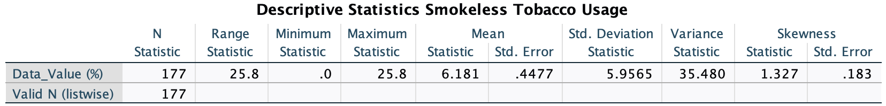

*Figure 2.1 Descriptive Statistics of Smokeless Tobacco Use*

The descriptive statistics for smokeless tobacco use categorized by education level indicate that high schoolers exhibit a higher mean usage rate (8.175%) with greater variability (standard deviation of 6.4711) compared to middle schoolers (mean of 3.469% and standard deviation of 3.7817, Figure 2.2).

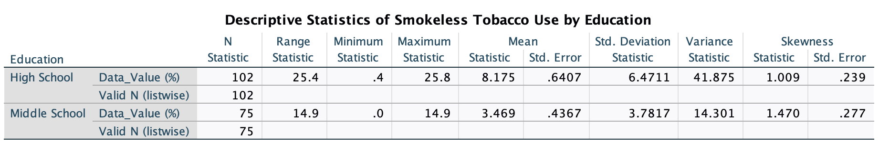

*Figure 2.2 Descriptive Statistics of Smokeless Tobacco Use by Middle and High School Youth*

**Cigarette Use**: Percentage of students who have reported smoking cigarettes recently.

The descriptive analysis of youth cigarette usage based on 177 observations reveals a mean prevalence rate of approximately 12.4% and a standard error of 0.95. The standard deviation of 12.77 and the variance of 163.055 indicate a high level of variability and a more spread-out distribution of data. It exhibited a wide range of 49.9, with a minimum of 0.1% and a maximum of 50%. The skewness value of 1.243 suggests that the distribution of cigarette use rates may be slightly positively skewed. (Figure 2.3).

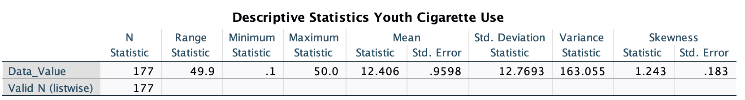 *Figure 2.3 Descriptive Statistics for Cigarette Use*

Furthermore, a descriptive analysis that compares the prevalence of cigarette use among high school and middle school students was conducted. The data shows that high school students have a higher mean (16.975%) compared to middle school students (6.191%). The observed difference in mean usage rates between the two education levels underscores the importance of investigating factors contributing to this variation (Figure 2.4).

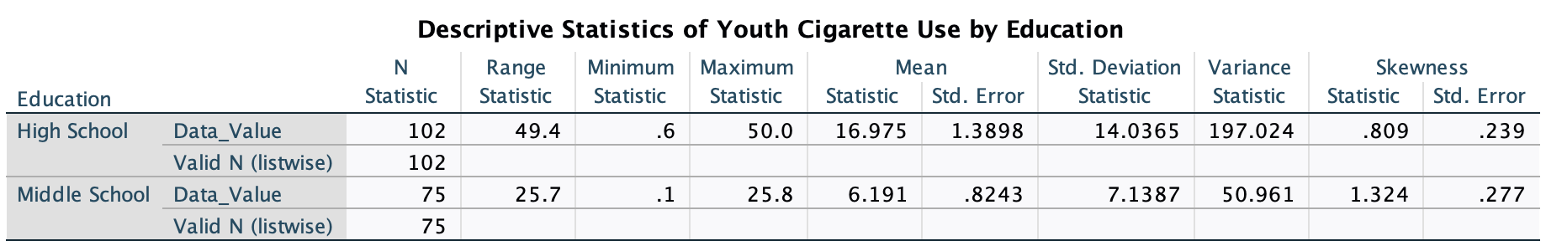

*Figure 2.4 Descriptive Statistics of Cigarette Use by Middle and High School Youth*

b. Tables, graphs

The figure below shows a bar chart of the tobacco use in mean percentages from 2010 to 2017. The graph reveals a fluctuating pattern consistent with our literature review, which indicated that tobacco use has not followed a steady trend over time. No constant upward or downward trends are observed; however, the highest tobacco use percentage occurred in 2011, whereas the lowest percentage was in 2016 (Figure 2.5).

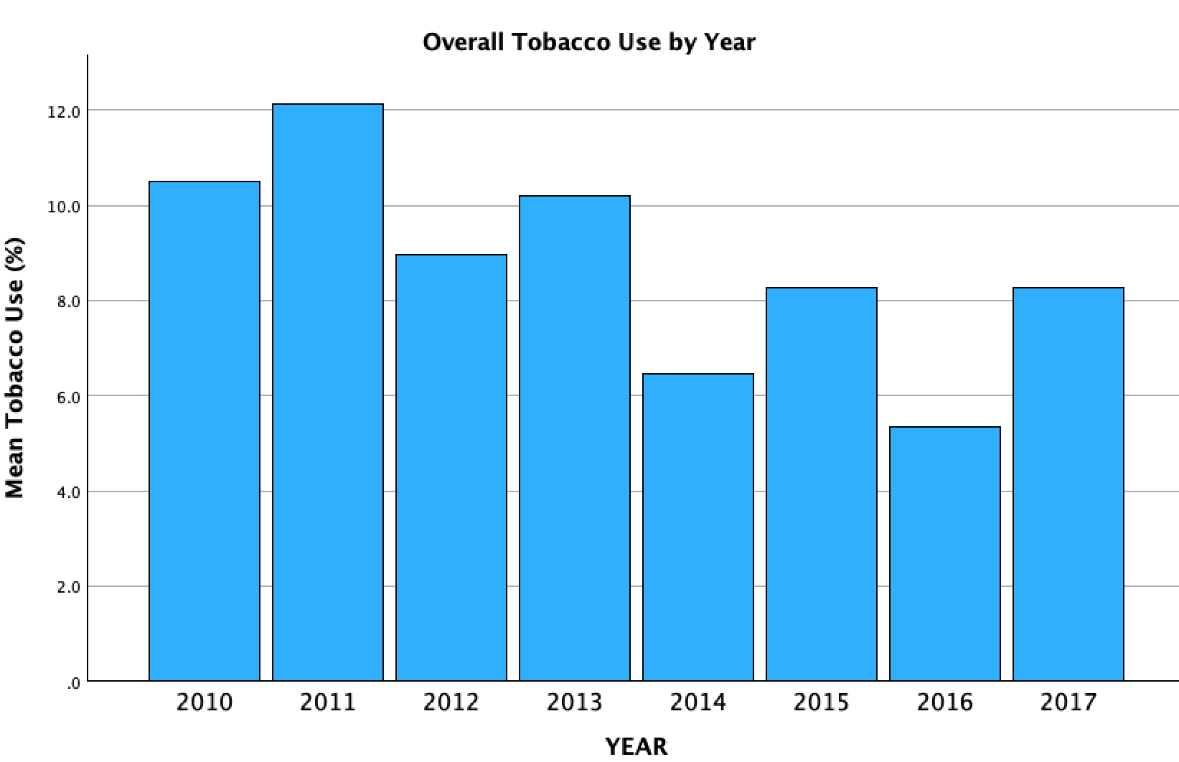

The figure below shows a clustered bar graph that compares tobacco use types (cigarette and smokeless tobacco) across education levels (high school and middle school). Overall, cigarette use emerged as the most prevalent type of tobacco used among both middle and high school students. Moreover, the graph shows high schoolers exhibiting a higher mean smoking percentage than middle schoolers. This graph displays consistent findings with our descriptive statistics tables (Figure 2.6).

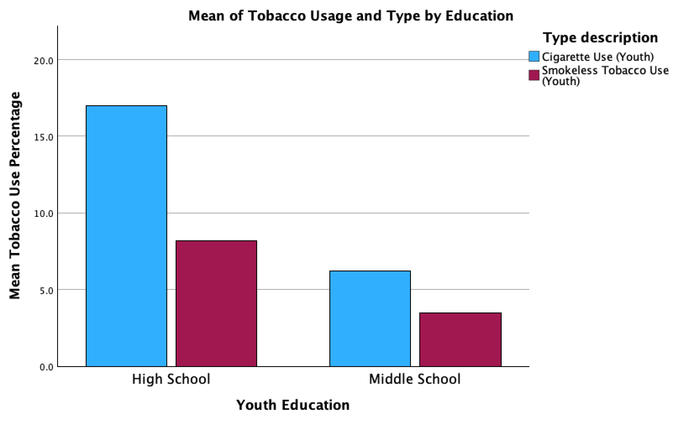

*Figure 2.6 The Mean of Tobacco Use by Middle and High School Youth*

c. Measures of Central Tendency and Measures of Dispersion

Overall the mean prevalence is approximately 6.181%, with a median of 4.000% and a mode of 3.5%. Along with the measure of central tendencies, we also found the measures of dispersion (standard deviation = 5.96, variance = 35.48, S.E mean = 0.477) to further understand the variability within the dataset (Figure 2.7a). Comparing the measures of central tendency and dispersion among the two groups (high school and middle school), it can be seen that the sample size for high schoolers (N=102) was higher than for middle schoolers (N=75) (Figure 2.7b).

The mean use rate among high school students is 8.175, with a standard error of 0.64. In comparison, those in a middle school have a mean use rate of 3.469%, with a standard error of the mean of 0.4367 (Figure 2.7b). These findings highlight a trend: generally, higher usage rates are observed among high school individuals compared to those in middle school.

Data_Value = % Smokeless Tobacco Use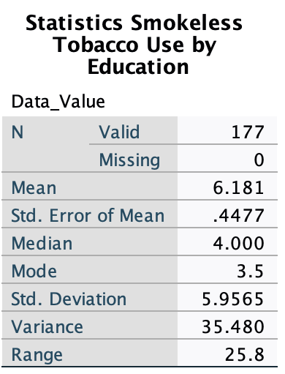

*Figure 2.7a Smokeless Tobacco Use Overall*

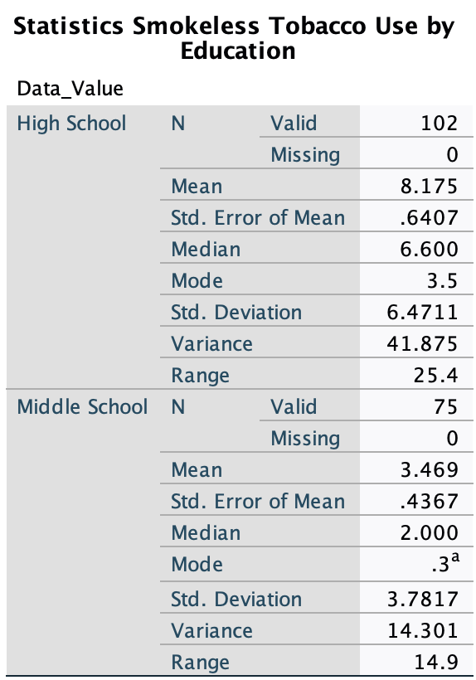

*Figure 2.7b Smokeless Tobacco Use Statistics by Middle and High School Youth*

The data collected from a sample of 177 middle and high school students reveals an average prevalence of cigarette use of 12.406%, with a median of 7.900% and a mode of 3.5% (Figure 2.8a). The sample, which includes a larger number of high schoolers (N=102) than middle schoolers (N=75), highlights the urgency of addressing adolescent cigarette use. The high school students (N=102) surveyed exhibited a significantly higher average cigarette use of 16.975%, with a median of 11.700% and a mode of 3.5%. In contrast, middle school students showed a low average cigarette use of 6.191%, with a median of 3.200% and a mode of 0.6% (Figure 2.8b).

Data_Value = % Smokeless Tobacco Use

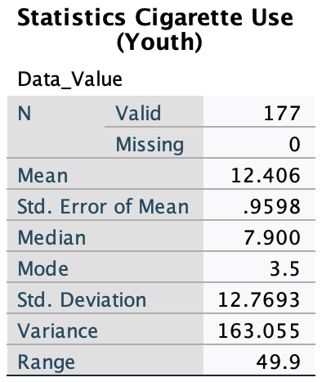

*Figure 2.8a Cigarette Use Overall Statistics*

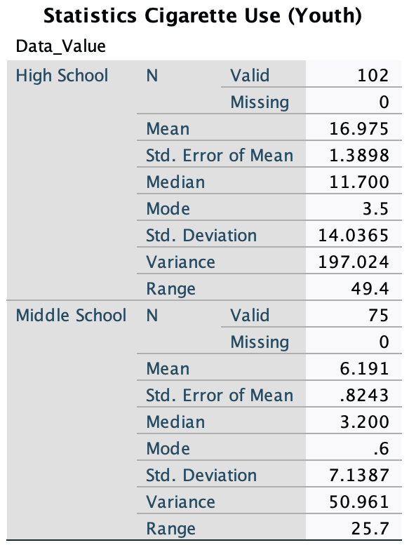

*Figure 2.8b Cigarette Use Statistics by Middle and High School Youth*

V. Statistical Analysis Part II: Inferential Statistics (30 points)

1. T Tests

In this research, we rely on Data Value variables, which is the percentage of students who have reported that they have access to cigarette or smokeless tobacco in each state, to perform the statistical tests and analysis. There are two independent groups of students with different education levels (middle school and high school students). Independent T tests of data value and education could not be carried out using this dataset because the data values from both groups are not normally distributed.

The Wilcoxon-Mann-Whitney test would be carried out instead. It can be applied to compare the differences between middle school and high school students with continuous data value which is not normally distributed. The four assumptions of the Wilcoxon-Mann-Whitney test are met. First of all, data value is continuous. Next, the independent variable (education) consists of two independent, categorical variables. Thirdly, they are independent groups. Lastly, the variables are not normally distributed.

Below is the histogram of data values of middle school students. From this graph, the distribution is right skewed which suggests that most middle school youths have access to tobacco, but the frequency is relatively low (Figure 3.1). However, there are a few exceptions that a small percentage of middle school students have frequent access to tobacco.

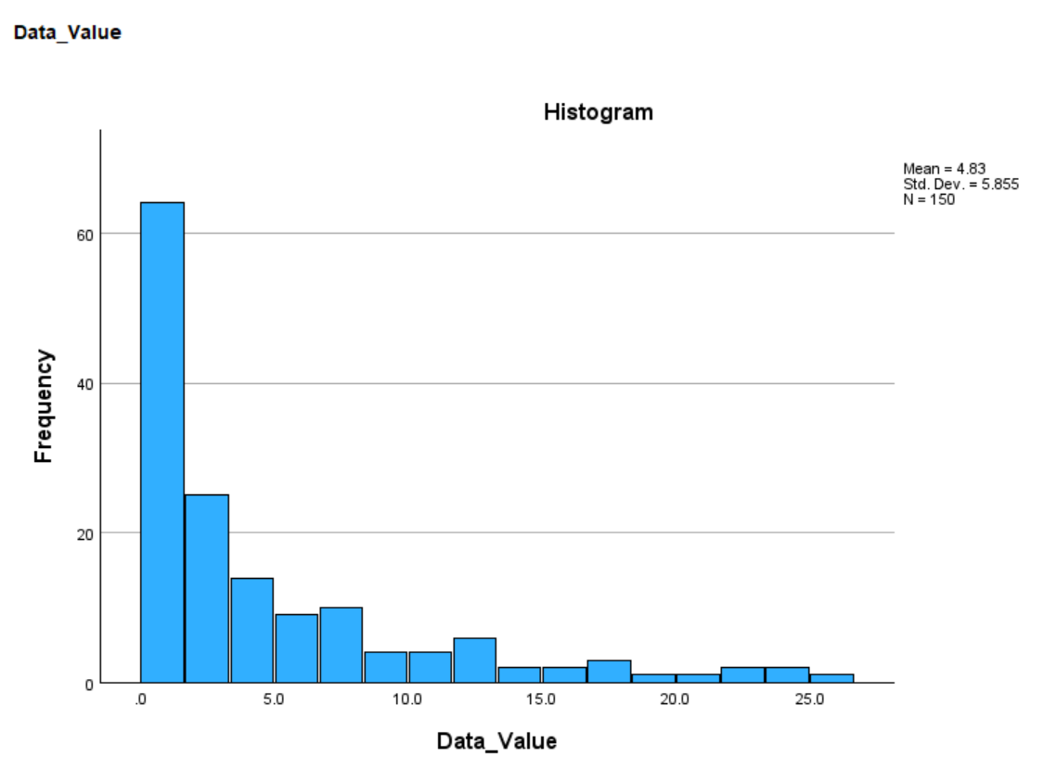

*Figure 3.1 Histogram of Middle School Youth Having Access to Tobacco*

Below is the histogram of data values of high school students. From this graph, the distribution is right skewed (Figure 3.2). The distribution suggests that most high school youths have little access to tobacco, but about 2 to 4 percent of youths have frequent access to tobacco.

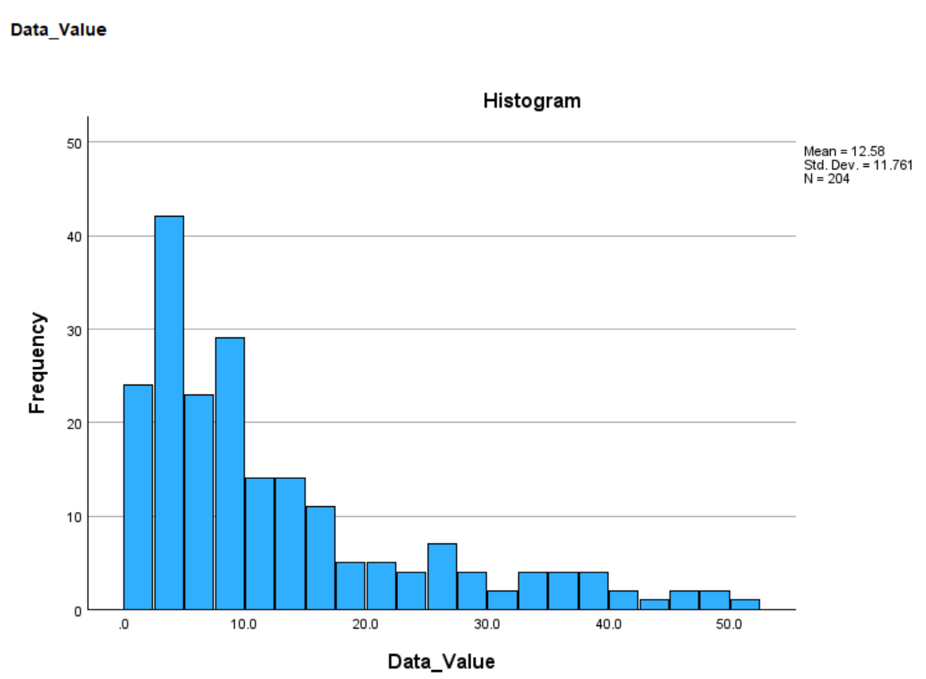

*Figure 3.2 Histogram Graph of High School Youth Having Access to Tobacco*

**The Wilcoxon-Mann-Whitney test**

The Mann-Whitney test is used to examine the difference in the data value of students with different education (middle school and high school). The significance in the result of the data value is found (U = 7289.5, p<0.0.5) (Figure 3.3). High school students average a 216.77, and middle school average a 124.16 (Figure 3.4). Middle school students exhibited notably better performance regarding tobacco use compared to high school students.

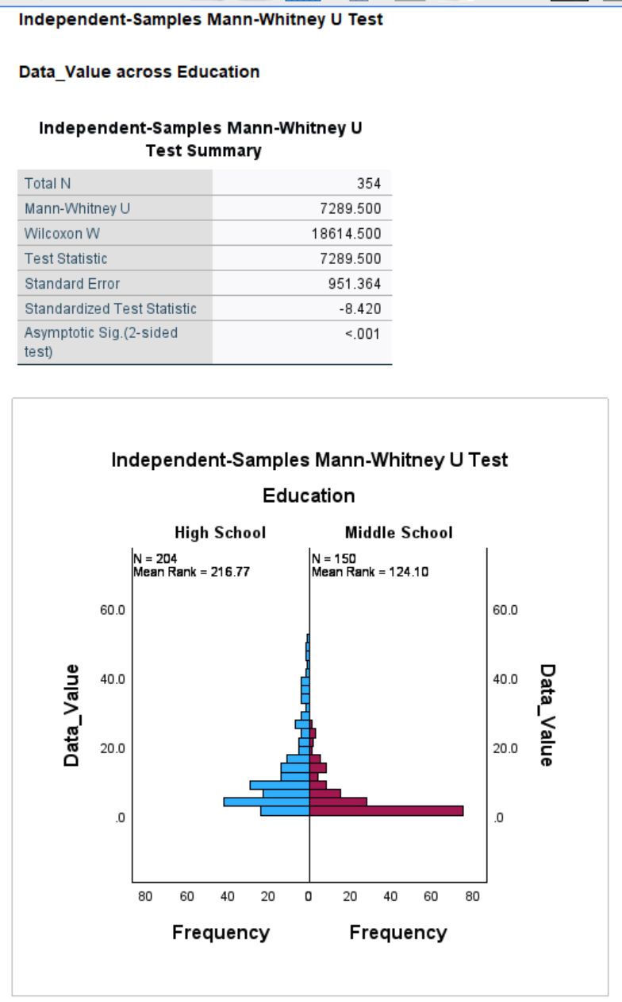

*Figure 3.3 Statistics of Wilcoxon-Mann-Whitney test*



*Figure 3.4 The Wilcoxon-Mann-Whitney Test Distribution of Middle and High School Youth Tobacco Use*

2. ANOVA

We computed a one-​way ANOVA comparing the data value of middle school and high school students in different years. A significant difference was found among the years ( F (7,346) = 1.654, p < .05) (Figure 3.5). Tukey’s HSD was used to determine the nature of the differences between the years (Figure 3.6). This analysis revealed that each year was not significantly different from either of the other two groups.

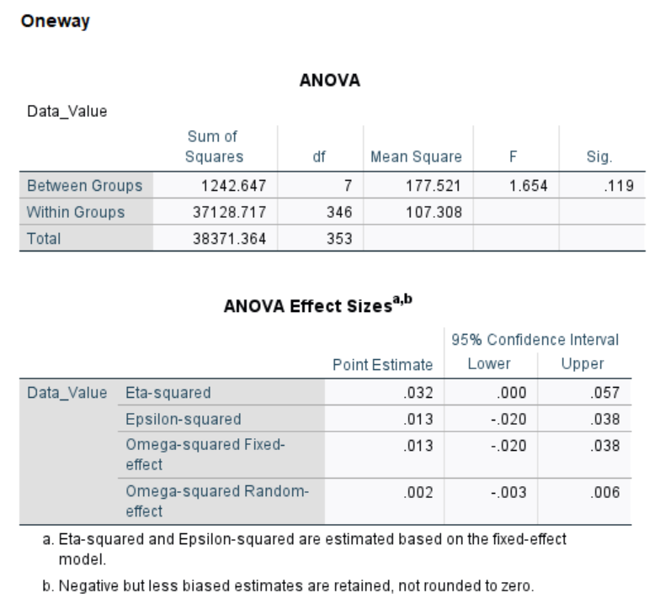

*Figure 3.5 One-way ANOVA Test for Middle and High School Youth*

3. Correlation

A Spearman *rho* correlation coefficient was calculated for the relationship between data value and education level. A moderate positive correlation was found between the access of tobacco and the education level (correlation coefficient is 0.448, p<0.001), indicating a significant relationship between the two variables (Figure 3.7). This correlation displays that high school students have more access to tobacco products compared to middle school students.

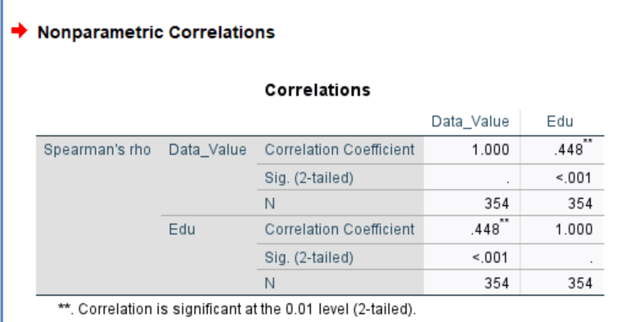

*Figure 3.7 Correlation Between Access to Tobacco and Education Level*

4. Regression

Linear regression would not be appropriate for the dataset. Education may not apply interval or ratio scale. Furthermore, the dependent variable (data value) is not normally distributed.

Result interpretation:

Based on the tests taken above, from the Mann-Whitney test, p < 0.05, we can reject the null hypothesis and conclude that there is a difference in tobacco use of high school students and middle school students. From the correlation, a moderate positive correlation was found between tobacco use and the education level (correlation coefficient is 0.448, p<0.001), indicating a significant relationship between the two variables. Based on these findings, we can conclude that high school students have higher rates of tobacco use than middle school students on the East Coast states throughout the years 2010 to 2017.

VI. Overall Results from Data Analysis (10)

Our research aimed to evaluate the use of tobacco among middle and high school students on the East Coast states: Delaware, New Jersey, Pennsylvania, Connecticut, Georgia, New Hampshire, North Carolina, South Carolina, and West Virginia from the year 2010 to 2017. Through descriptive analysis, we found that both types of tobacco: cigarette and smokeless tobacco use varied over the study period. More importantly, descriptive statistics imply that high school students have a higher rate of tobacco use compared to middle school students. Measures of central tendency and dispersion also highlight that high school students show more use of tobacco (both cigarette and smokeless tobacco use) than middle school students. The bar graph comparing the use of tobacco among middle and high school youth shows higher use of tobacco in high school youth as well (Figure 2.6). Due to the values not being normally distributed in our dataset, the Wilcoxon-Mann-Whitney test was conducted instead of the T-test. This test demonstrates that middle school youths exhibit significantly lower rates of tobacco use in comparison to high school youths. The results of descriptive and inferential statistical analyses, as well as the Wilcoxon-Mann-Whitney test align with what we have researched prior to this study. The literature review explores the trends in tobacco use among middle and high school youth, suggesting that high school students have a worse performance in tobacco use. According to research, 11.7% of high school students and 5.6% of middle school students were identified as current users of any tobacco products (Anic et al., 2018).

Based on our analysis and performing tests with the literature review, we reject the null hypothesis. Our findings show that there is a significant difference between the use of tobacco among middle and high school students. We support the alternative hypothesis that high school students have a higher rate of tobacco use compared to middle school students on the East Coast states throughout the years 2010 to 2017. Rejecting the null hypothesis holds significance for understanding youth tobacco use patterns. It suggests that there should be interventions targeting and tailoring to different age groups. Additionally, it also suggests that early prevention efforts are needed to reduce the use of tobacco in middle school youth to minimize the usage transition to high school youths.

VII. Conclusion and Recommendations (10)

Our study identified many areas where the current research could be improved. This includes the need for a comprehensive analysis of the factors influencing tobacco use disparities among middle and high school students. It lacks studies that examine the effects of advice from health providers, tobacco prevention programs, and tobacco screenings on usage rates. While the study provides valuable insights into tobacco use trends during the specified period, there remains a need for longitudinal analysis to track these trends over a more extended timeframe to get a better understanding of the evolving patterns of youth tobacco use.

Building upon the foundation laid by this research project, future studies could conduct qualitative research to explore the factors (attitudes, beliefs, and social influences) that lead to middle and high school students' tobacco usage. This would allow us to get a better understanding of why middle schoolers have lower tobacco usage compared to high schoolers. Comparing and contrasting the effectiveness of different interventions and programs will help develop more effective prevention strategies. Additionally, future studies should compare the East Coast trends with those in other regions (West Coast, Midwest, Southern states) to get insight into regional differences in youth tobacco usage.

To expand the current study, researchers should consider conducting a longitudinal analysis with an increased sample size to improve generalizability and trends exploration. Additionally, incorporating qualitative data collection methods and variables such as socioeconomic status, parental smoking behavior, peer influence, access to cessation resources could provide richer contextual understanding of tobacco use. In-depth interviews and focus groups are appropriate qualitative methods. Focus groups can facilitate the exploration of shared experiences and should be structured around key topics we’ve identified in the literature review such as norms, advertisement influence etc. The in-depth interview will provide a more detailed exploration of students' experience without influence of group dynamics.

The literature review has shown that advertisements are a factor for increased tobacco usage. A new direction for our research could be the exploration of the impact of social media and digital marketing on youth tobacco use behaviors. Adolescents are exposed to digital marketing tactics promoting tobacco products and vaping devices daily. Researchers should investigate the current regulations and the strategies used by tobacco companies to target youth through social media, as they could offer innovative strategies for addressing youth tobacco use in the digital age.

Conclusion

In conclusion, our research provided insights into youth tobacco use patterns among middle and high school students in the East Coast states from 2010 to 2017. Through a combination of literature review, descriptive analysis, and inferential statistical tests, we found that high school students exhibit higher rates of tobacco use, in both cigarette and smokeless, compared to middle school students. These results align with the prior research discussed in the literature review. By rejecting the Null hypothesis and highlighting differences in tobacco use between middle and high school students, we provide insights that can inform targeted interventions and policy initiatives aimed at reducing youth tobacco use rates. Reflecting on the research process, we encountered a challenge in interpreting complex statistical analyses because our dataset was not normally distributed. This prevented us from conducting the T-test as planned initially. Going forward, it is crucial to keep researching, making policies, and taking action to tackle this health problem and ensure a better future for the next generations.

**REFERENCE**

1. Anic, G. M., Sawdey, M. D., Jamal, A., & Trivers, K. F. (2018). Frequency of Use Among Middle and High School Student Tobacco Product Users - United States, 2015-2017. MMWR. Morbidity and mortality weekly report, 67(49), 1353–1357. [https://doi.org/10.15585/mmwr.mm6749a](https://doi.org/10.15585/mmwr.mm6749a1)1
2. Wiggins, A. T., Huntington‐Moskos, L., Rayens, E. A., Rayens, M. K., Noland, M., Butler, K., & Hahn, E. J. (2019). Tobacco use among rural and urban US middle and high school students: National Youth Tobacco Survey, 2011‐2016. The Journal of Rural Health, 36(1), 48–54. https://doi.org/10.1111/jrh.12356
3. Dube, S. R., Arrazola, R. A., Lee, J., Engstrom, M., & Malarcher, A. (2013). Pro-tobacco influences and susceptibility to smoking cigarettes among middle and high school students—United States, 2011. *Journal of Adolescent Health*, *52*(5). https://doi.org/10.1016/j.jadohealth.2012.07.007
4. National Center for Chronic Disease Prevention and Health Promotion (US) Office on Smoking and Health. Preventing Tobacco Use Among Youth and Young Adults: A Report of the Surgeon General. Atlanta (GA): Centers for Disease Control and Prevention (US); 2012. 2, The Health Consequences of Tobacco Use Among Young People. Available from: <https://www.ncbi.nlm.nih.gov/books/NBK99242/>
5. Boakye, E., Osuji, N., Erhabor, J., Obisesan, O., Osei, A. D., El Shahawy, O., & Blaha, M. J. (2023). Healthcare Provider Screening for Tobacco Product and Electronic Cigarette Use Among Youth in the United States. Journal of Adolescent Health, 72(5), 819–822. <https://doi.org/10.1016/j.jadohealth.2022.12.004>
6. Mills, R., Mann, M. J., Smith, M. L., & Kristjansson, A. L. (2021). Parental support and monitoring as associated with adolescent alcohol and tobacco use by gender and age. BMC public health, 21(1), 2000. https://doi.org/10.1186/s12889-021-12119-3IF: 4.5 Q2

**APPENDIX**

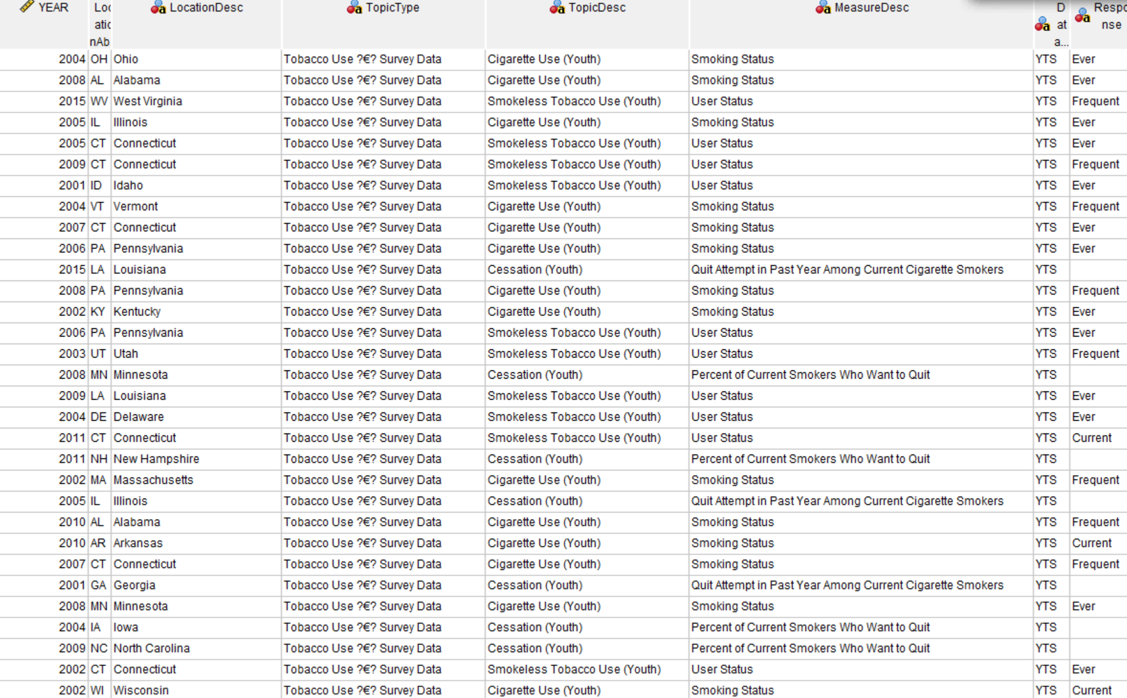

*Figure 1.1 Youth Tobacco Survey Original Dataset*

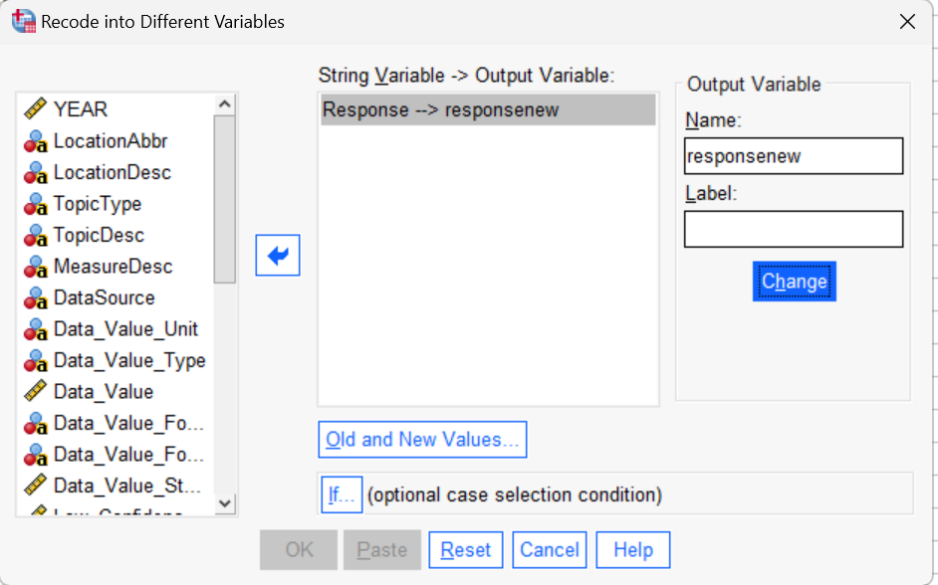

*Figure 1.2 Creating New Column for the Response Variables*

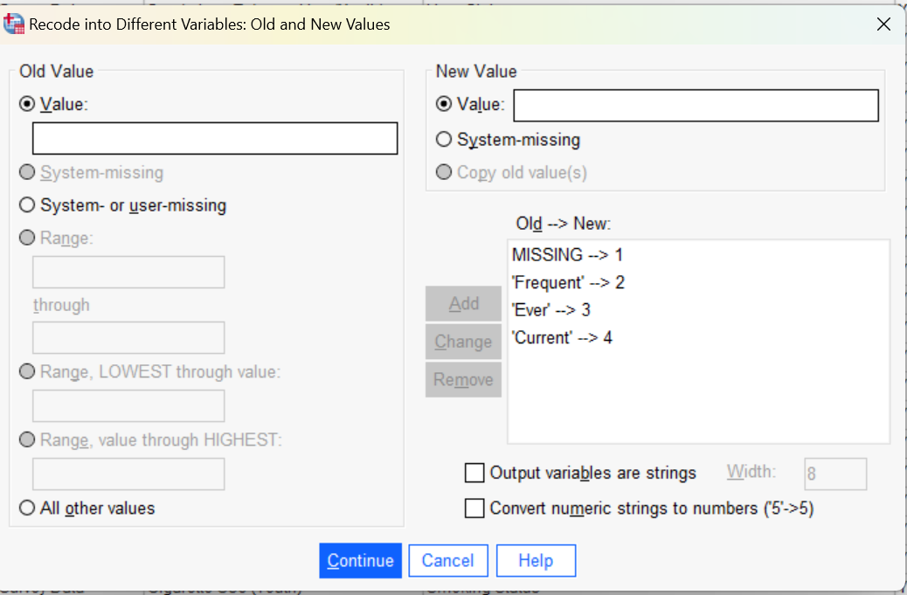

*Figure 1.3 Transforming Response Variables into Numeric Values*

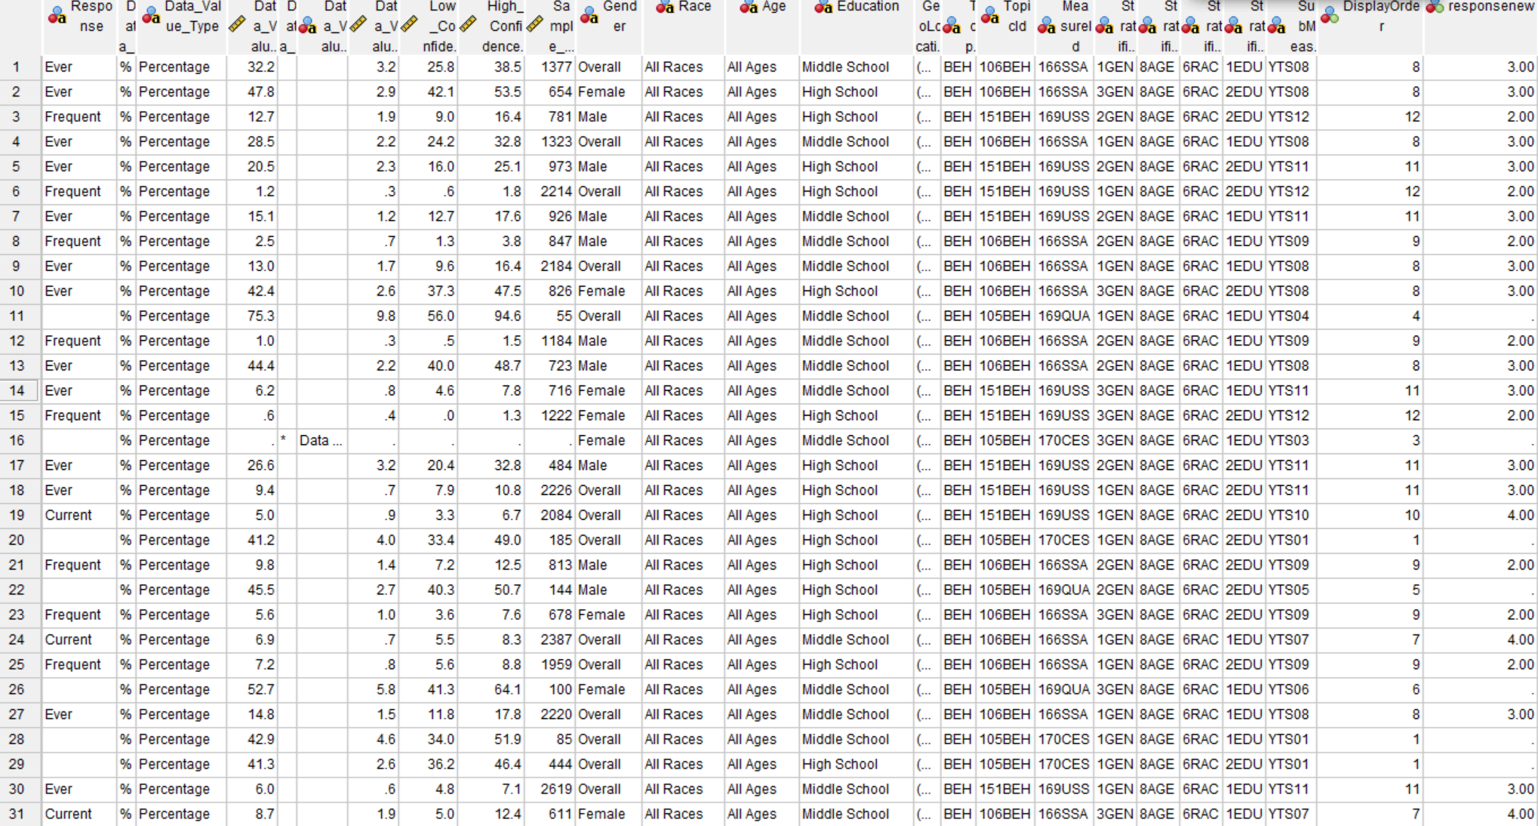

*Figure 1.4 Numerical Values of Tobacco Use Response Created*

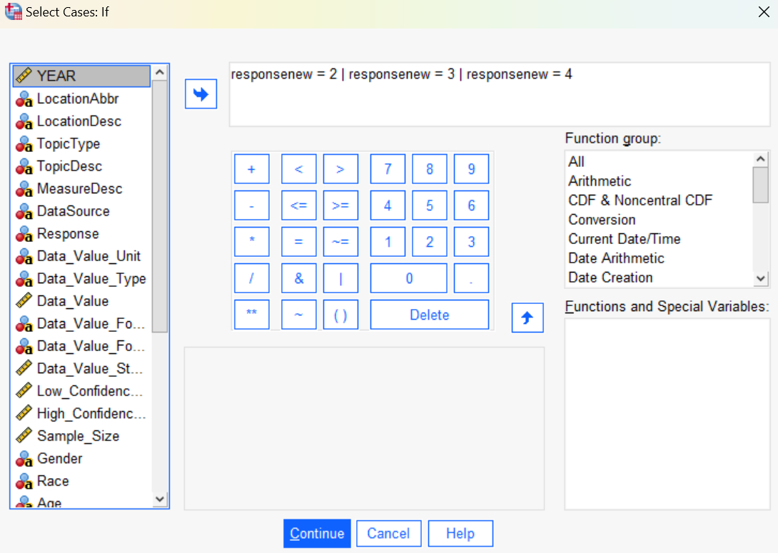

*Figure 1.5 Select Cases Condition: Selecting String Values to Keep*

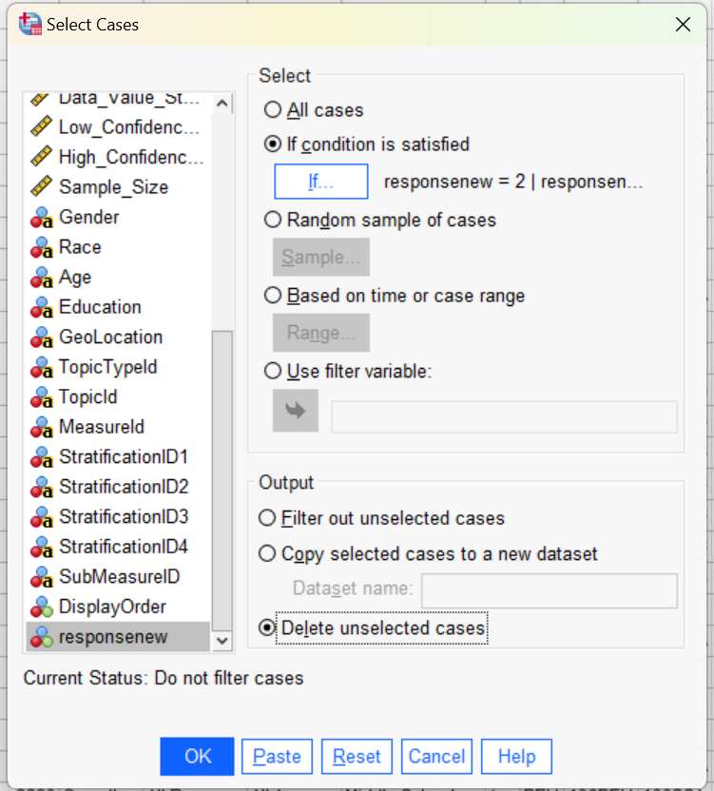

*Figure 1.6 Removing Missing Values(responsenew = 1)*

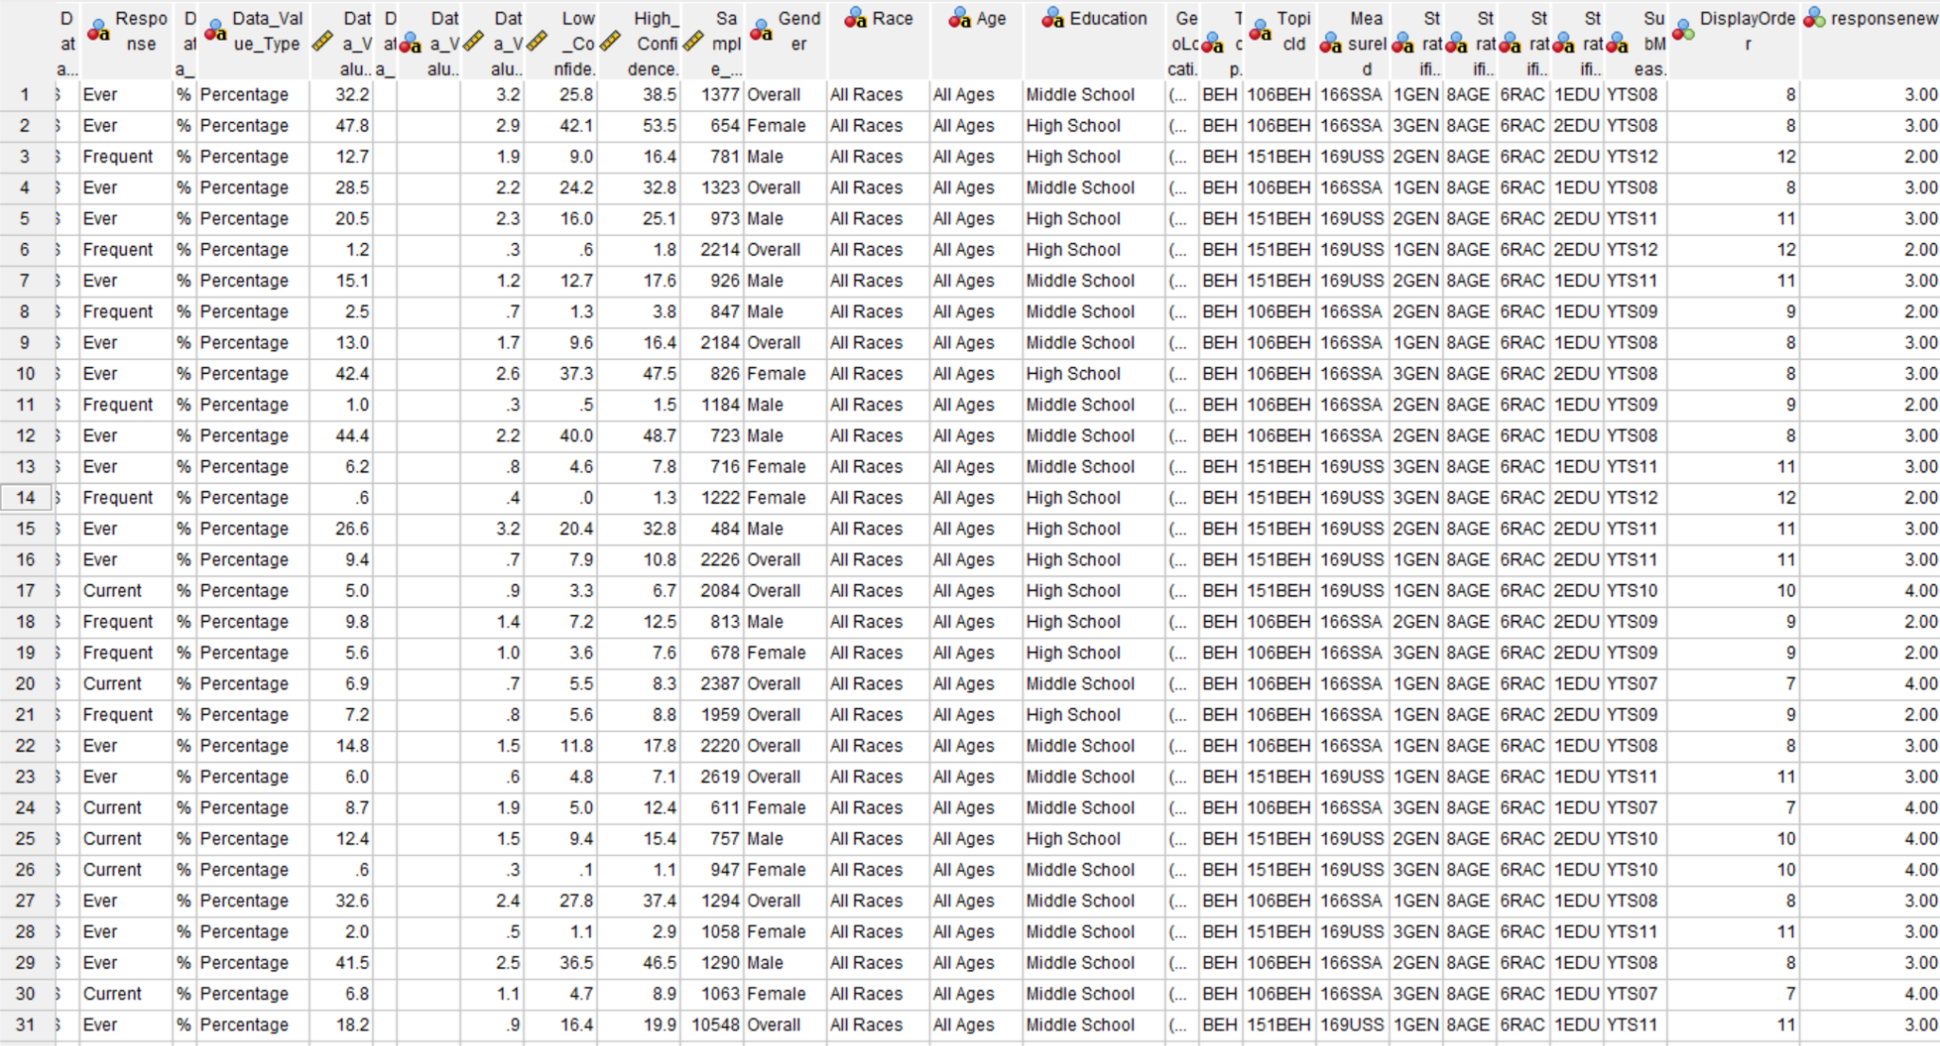

*Figure 1.7 Data Table without Missing Values*

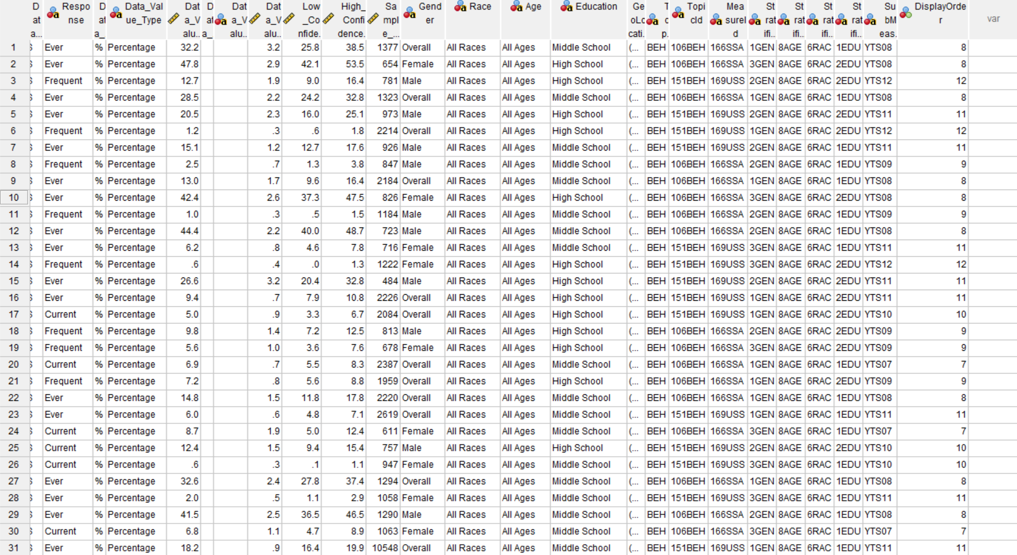

*Figure 1.8 New Dataset Excluding responsenew Column*

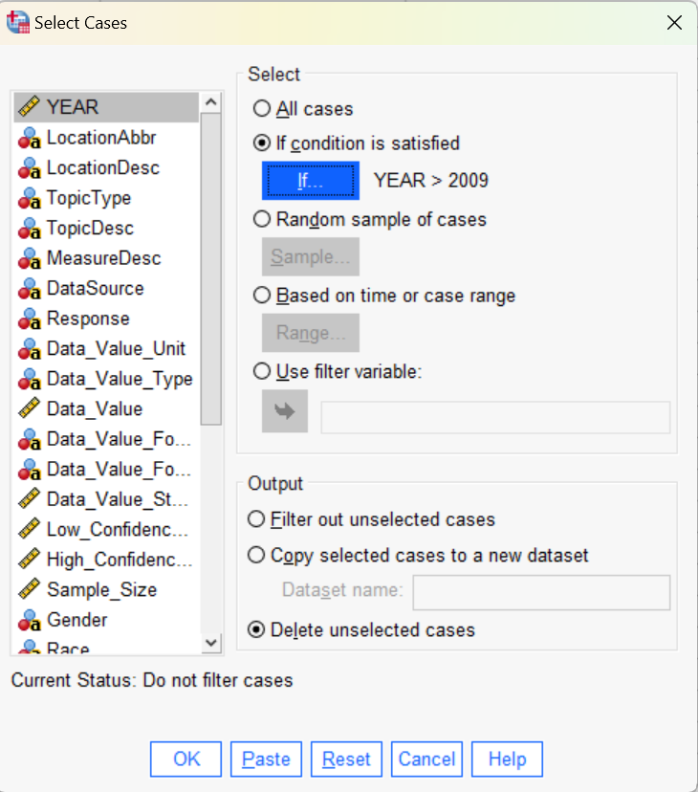

*Figure 1.9 Filtering out the Years Before 2010*

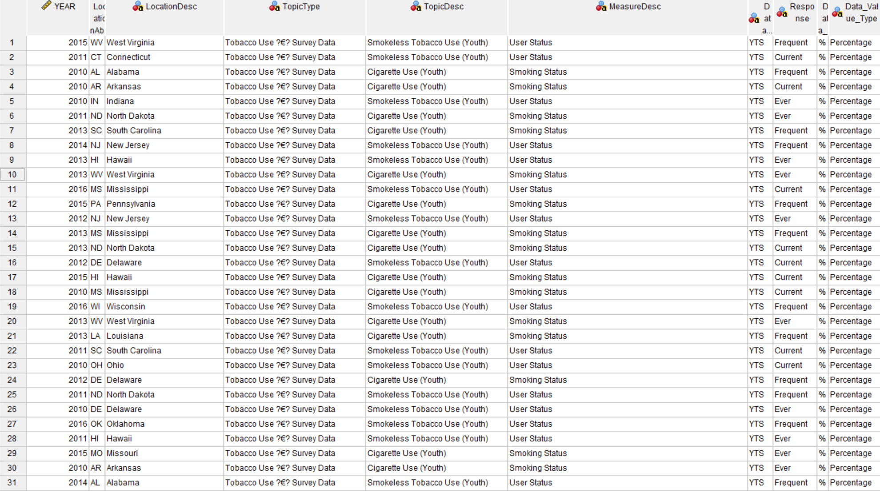

*Figure 1.10 Tobacco Survey Dataset after Filtering the Year Range 2010 to 2017*

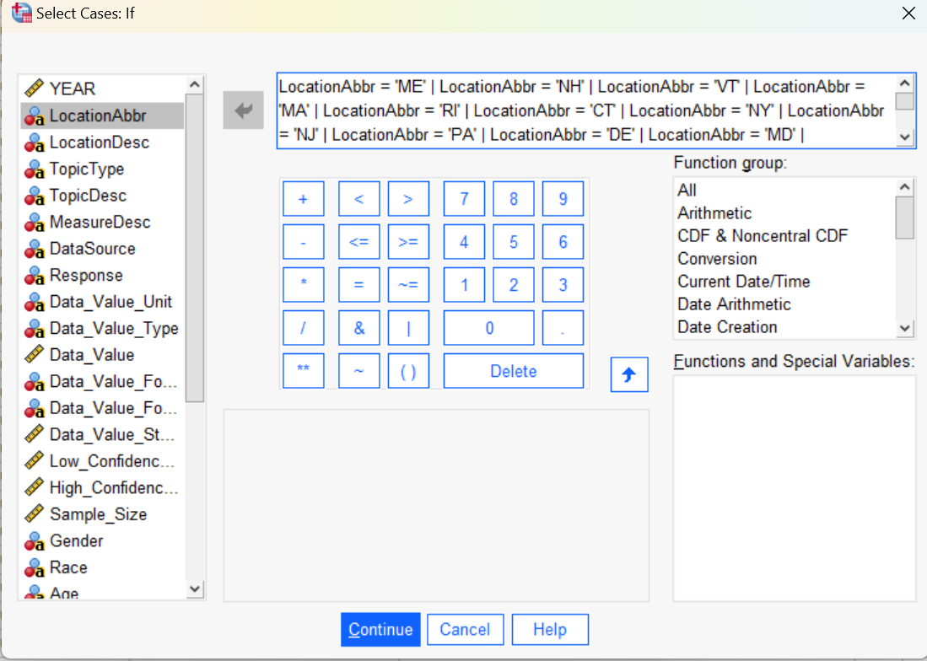

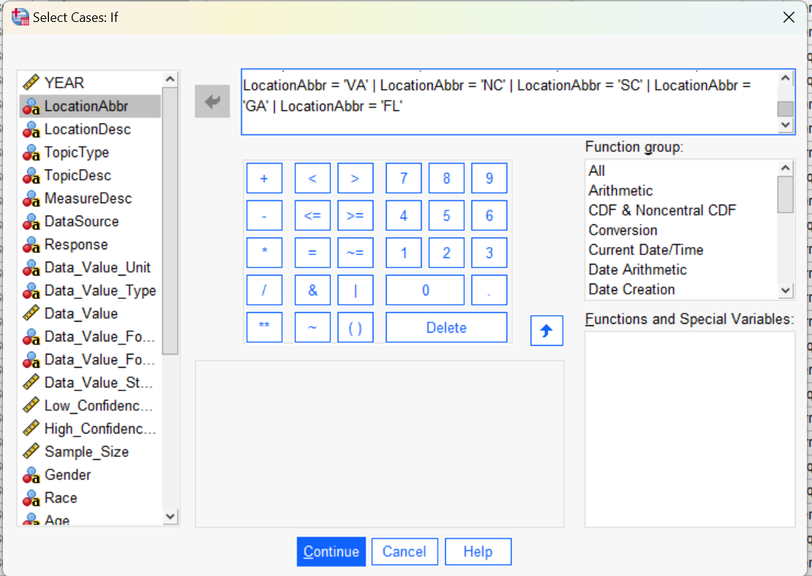

*Figure 1.11 Selecting the East Coast States*

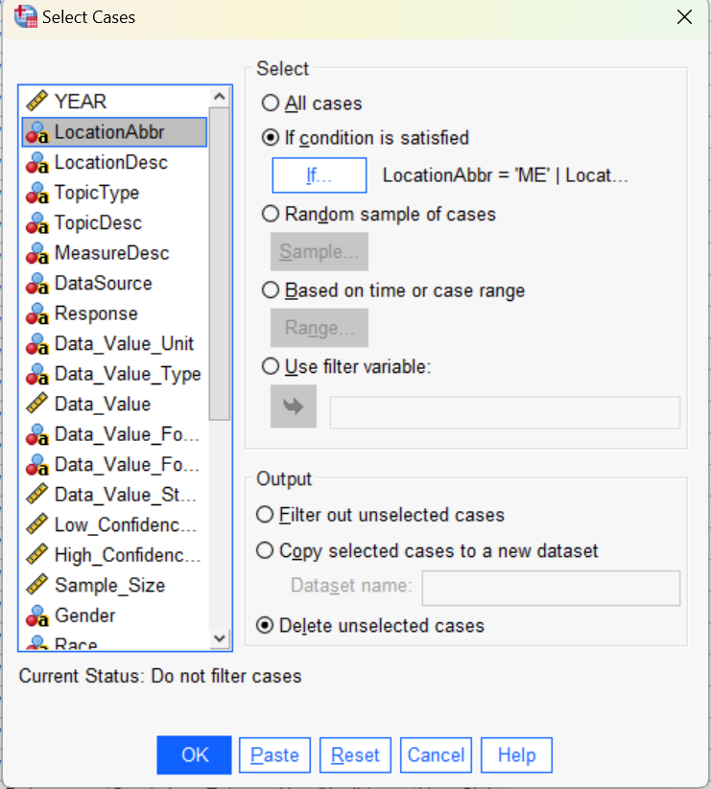

*Figure 1.12 Deleting Unselected States from the Dataset*

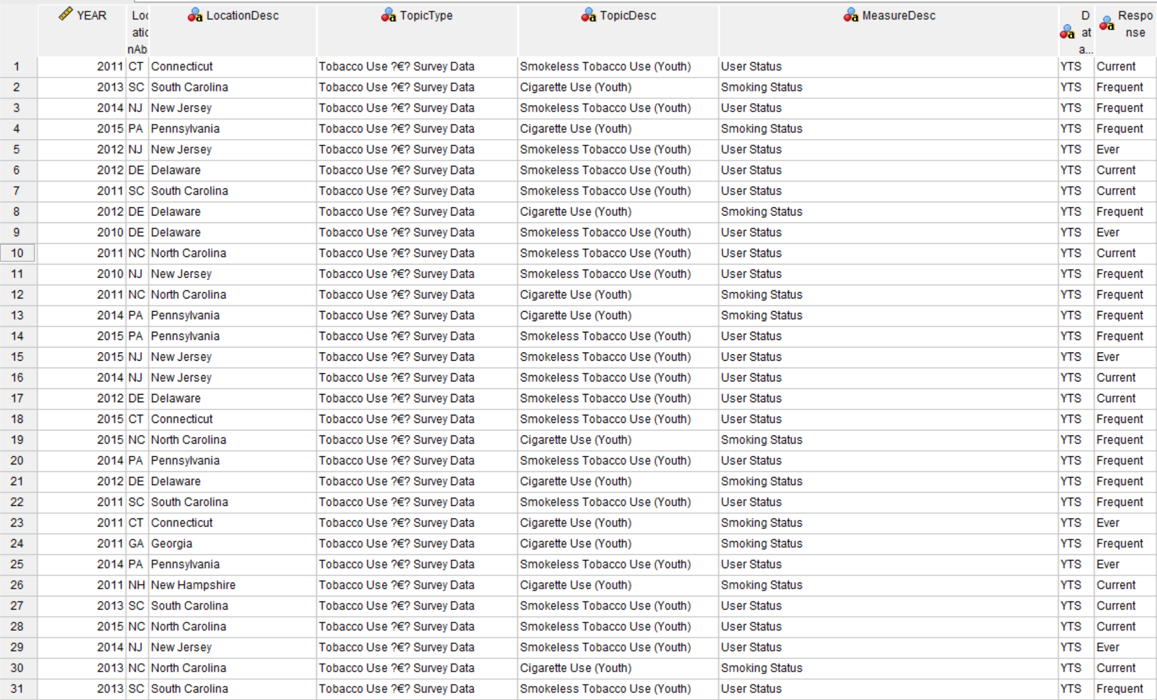

*Figure 1.13 Dataset with Selected States on the East Coast*

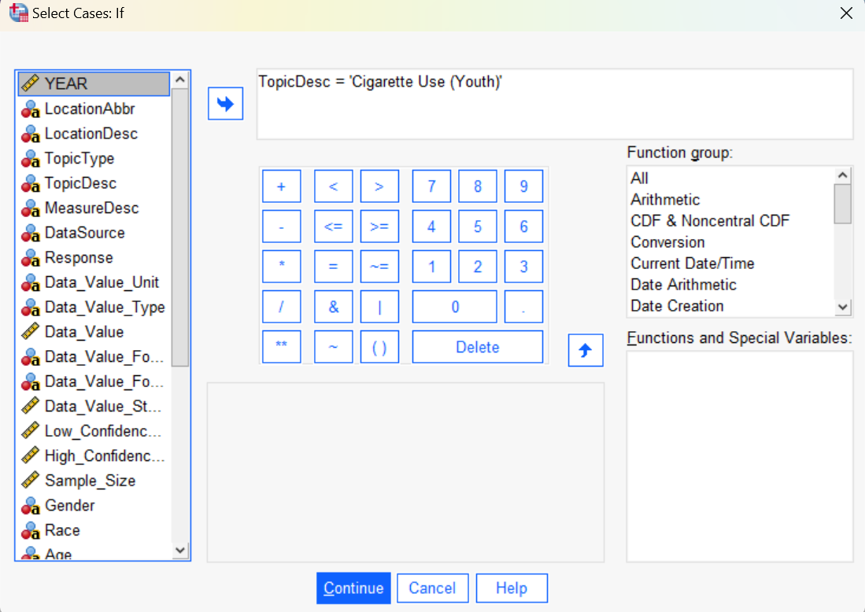

*Figure 1.14 Selecting the Data Containing Cigarette Use*

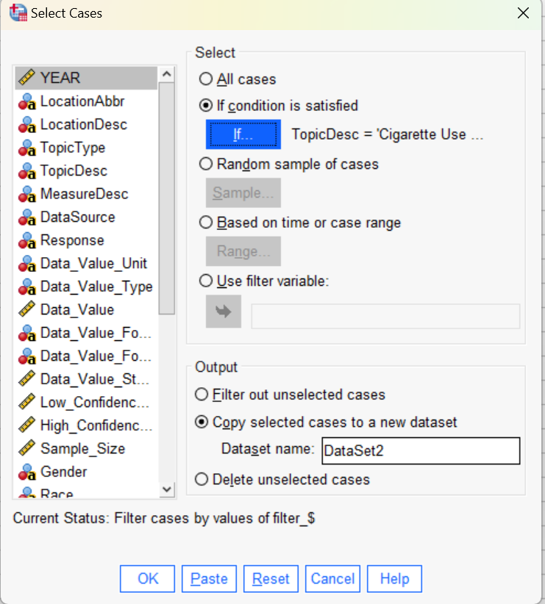

*Figure 1.15 Copying the Cigarette Use Data into a New Dataset*

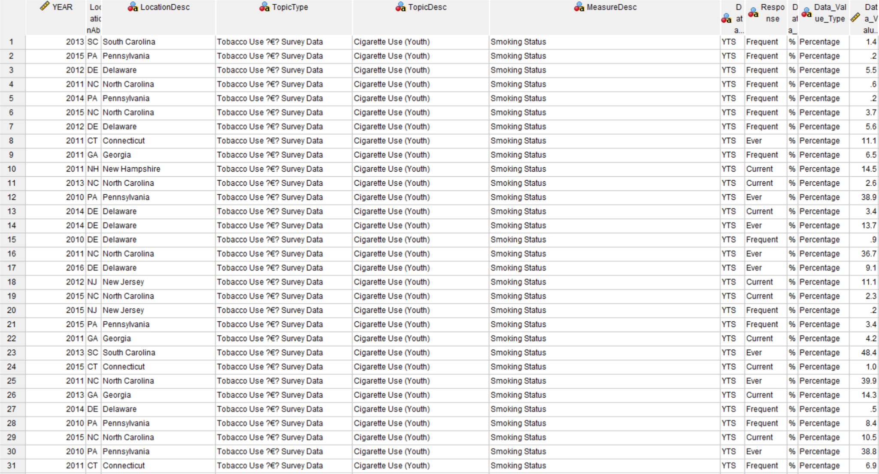

*Figure 1.16 Cigarette Use Dataset after Extraction*

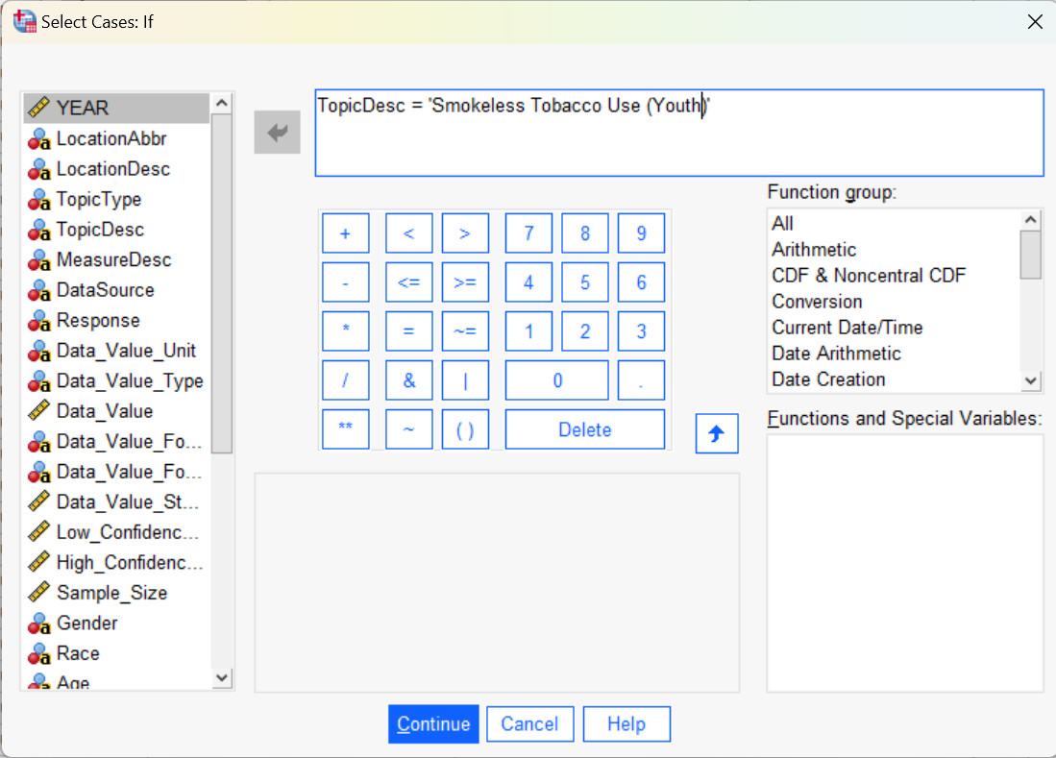

*Figure 1.17 Selecting the Data Containing Smokeless Tobacco Use*

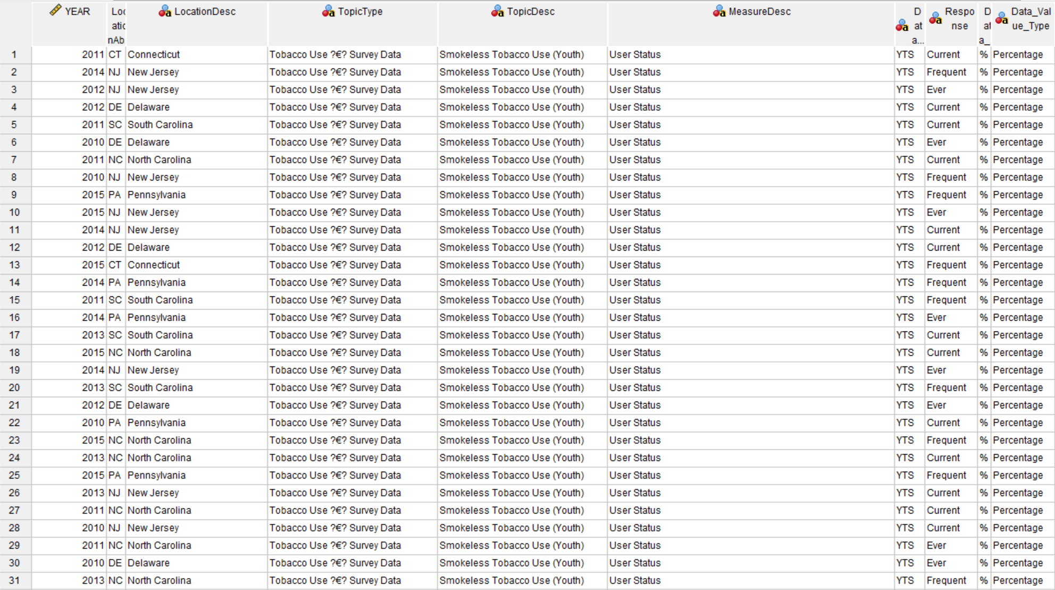

*Figure 1.18 Smokeless Tobacco Use Dataset after Extraction*

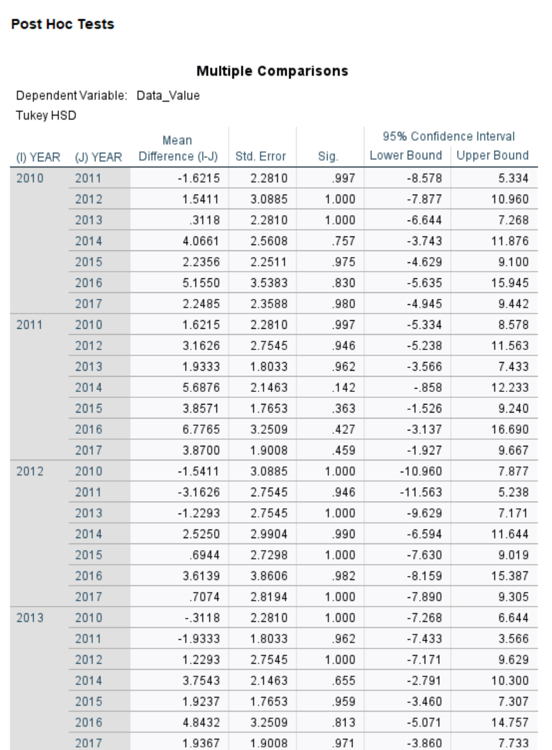

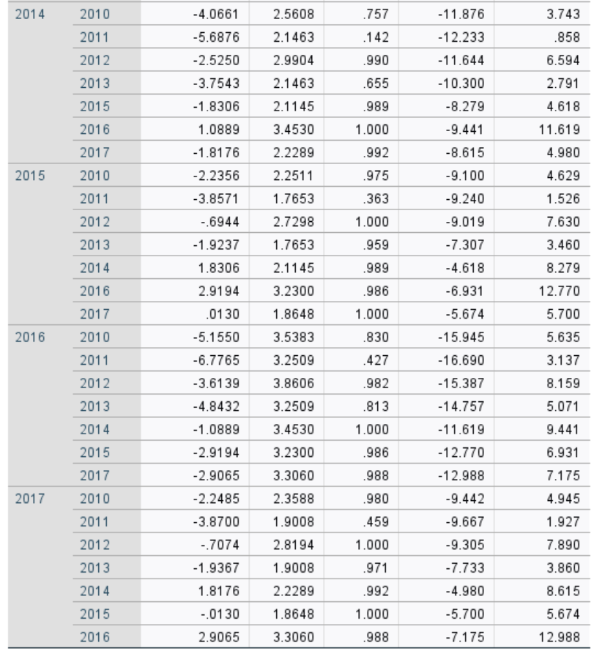

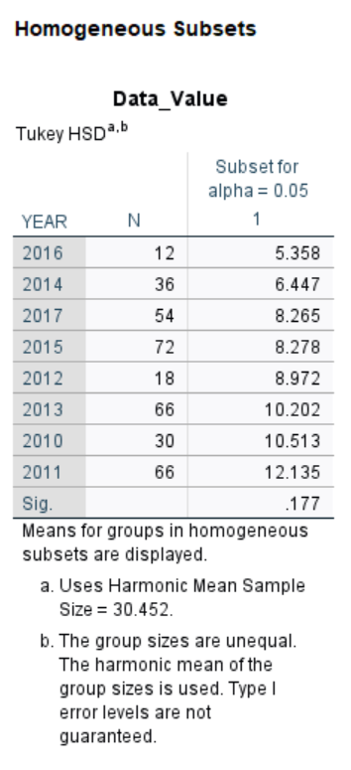

*Figure 3.6 Tukey's Honest Significant Difference (HSD) Test Results*